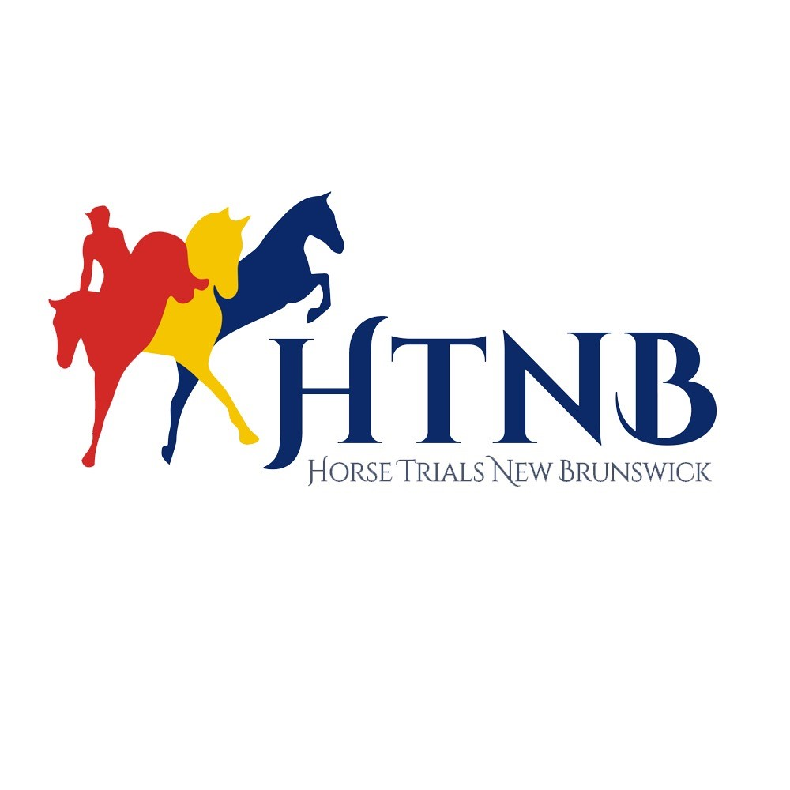
HTNB CLINIC SERIES

(FLIGHT & FANCY: Dressage & Stadium Jumping)
(May 14, 2022)

Clinic open to ALL. Must have a PTSO (Provincial Sport Organization ie: NBEA) and HTNB membership as well as proof of up-to-date vaccines and Coggins to participate. Registration fee is $100 and can be e-transferred to SuzanneStevenson@nb.sympatico.ca. Entry form to be sent to horsetrialsnb@gmail.com no later than May 11th.

ENTRY FORM

Rider Name: _______________________________ Date of Birth: __________________

Horse’s Name: _____________________________ Date of Birth: __________________

Phone #: _____________________________ Email: ____________________________

Coaches you have worked with on a regular basis: _______________________________________

Highest Rider Level Achieved: __________________

Rider’s Horse Trial / Eventing Experience / Highest Division: _____________________________

Horse’s Horse Trial / Eventing Experience (Highest Division): _____________________________

PTS# ___________ EC# (if applicable____________________
HTNB#: __________________

Check which Division you wish to ride:

Starter – Dressage (Entry Test #1), Jumping (max. 2’)

Pre-Entry – Dressage (Entry Test #2), Jumping (max. 2’6”)

Entry – Dressage (Entry Test #2), Jumping (max 2’9”)

Pre-Training – Dressage (Pre-Training Test #2), Jumping (max 3’)

- Training – Dressage (Training Test #2), Jumping (max 3’3”)

Clinicians & Clinic Format:

Dressage - Participants will ride the dressage test of their division, get feedback on their test, and one-on-one instruction for improving their score by clinician, Donna McInnis (Certified Competitive Coach and Judge).

Stadium Jumping - Session will focus on gymnastics, combinations, and other stadium jumping exercises with Rob Stevenson (Certified Competition Coach Specialist).

Ride times will be scheduled and emailed to participants prior to clinic.

Foshay South, 16 Gallaway Drive, Lakeside, NB E5N 0K9
Foshay Jemseg, 52 Jemseg Ferry Road, Jemseg, NB E4C 3R5

